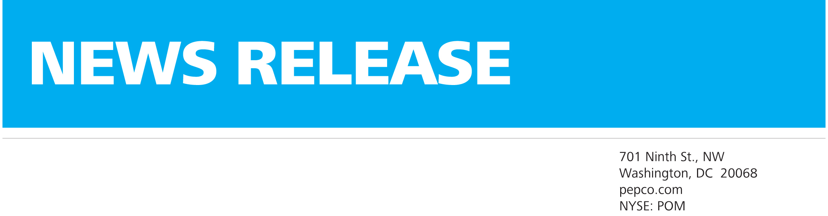Need Help Paying Your Utility Bill?

For Immediate Release | Dec 2, 2013

Media Contact: Frank Tedesco

Office 609-625-5567 | 24/7 Media Hotline 1-866-655-2237 | frank.tedesco@pepcoholdings.com

5100 Harding Highway

Mays Landing, NJ 08330

atlanticcityelectric.com

NYSE: POM

Atlantic City Electric Reminds Customers Assistance is Available

MAYS LANDING, N.J. – Atlantic City Electric customers have numerous options in which to apply for energy assistance. Atlantic City Electric wants its customers to know there is help available now if they are having difficulty paying their energy bills.

The **TRUE Grant** program assists customers who are ineligible for low-income programs by providing up to $750 toward their Atlantic City Electric bill. Visit[www.ahanjtrue.org](http://www.ahanjtrue.org/) or call 732-982-8710 for more information.

**The Universal Service Fund (USF)** helps ensure energy bills are more affordable for eligible customers. Visit www.energyassistance.nj.gov or call 800-510-3102.

**The New Jersey Statewide Heating Assistance and Referral for Energy Services (New Jersey SHARES)** program provides assistance to New Jersey customers in need of temporary help paying their energy bills. New Jersey SHARES is a statewide, nonprofit 501(c) (3) organization which provides grants to pay the energy and utility bills of households in need, through a statewide network of more than 250 community-based [social service agencies](http://www.njshares.org/whereToApply/index.asp). Visit www.njshares.org or call 866-657-4273.

The federally funded **Low Income Home Energy Assistance Program (LIHEAP)** provides help for numerous households each year. Call 800-510-3102 or visit [www.energyassistance.nj.gov](http://www.energyassistance.nj.gov) for details.

**Lifeline** is a utility assistance program that offers $225 to persons who meet certain income guidelines. This benefit includes utility customers as well as tenants whose utility bills are included in their rent. Call 800-792-9745 for information.

For more information about energy assistance programs, visit [www.nj211.org](http://www.nj211.org) or call 211 - New Jersey’s non-emergency helpline, available 24/7 throughout the state.

Customers can also contact Atlantic City Electric’s Customer Care Center at 1-800-642-3780 and ask about Budget Billing or register for *My Account,* a web-based interactive tool that is free and easy to use. *My Account* provides customers with a detailed analysis of their specific electric use and offers ways to save energy and save money on their monthly energy bill.

(MORE)

As with all programs, there are restrictions so please call for eligibility requirements. Atlantic City Electric also wants to remind customers that conserving energy can lead to savings.

Customers can conserve energy by doing the following:

* During the winter months, turn down your thermostat from 72°F to 68°F for 8 hours a day and you'll save as much as 10% on energy costs. Every degree you lower your thermostat could save you about 3% on your heating bill.
* Winterize windows with weather stripping (for all moveable joints) and caulk (for non-moving parts). Also, install a window kit to the inside of your windows to help keep cold air out and warm air in.
* Change filters once a month. A well-maintained heating system can save money and increase the comfort level in your home.
* When you cozy up to a crackling fire on a cold winter day, you may be losing more heat than you are generating if your fireplace is not airtight.
* Inspect ductwork for any air leakage. If you do feel air leaking at joints, use silver metal duct tape to seal them. You could save up to 10% of your heating costs by eliminating those leaks.

Find additional information by visiting www.atlanticcityelectric.com, on Facebook at www.facebook.com/atlanticcityelectric and on Twitter at www.twitter.com/acelecconnect. Our mobile app is available at [www.atlanticcityelectric.com/mobileapp](http://www.atlanticcityelectric.com/mobileapp).

Atlantic City Electric News Release Month Day, Year

Page 2